# **Feature Scaling part-1**

🡪 to run gradient descent run much faster  
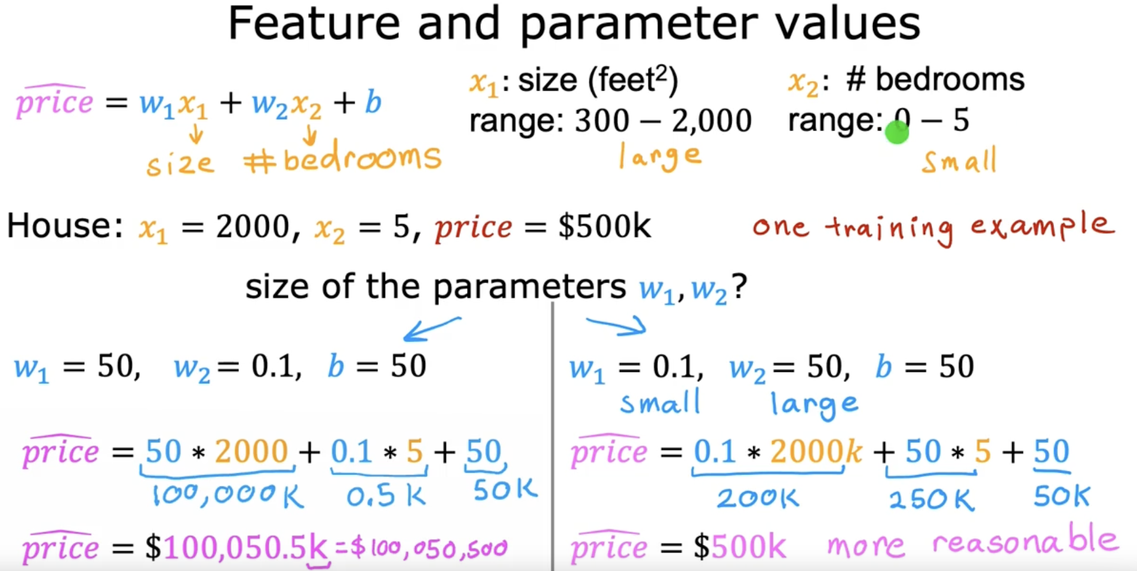

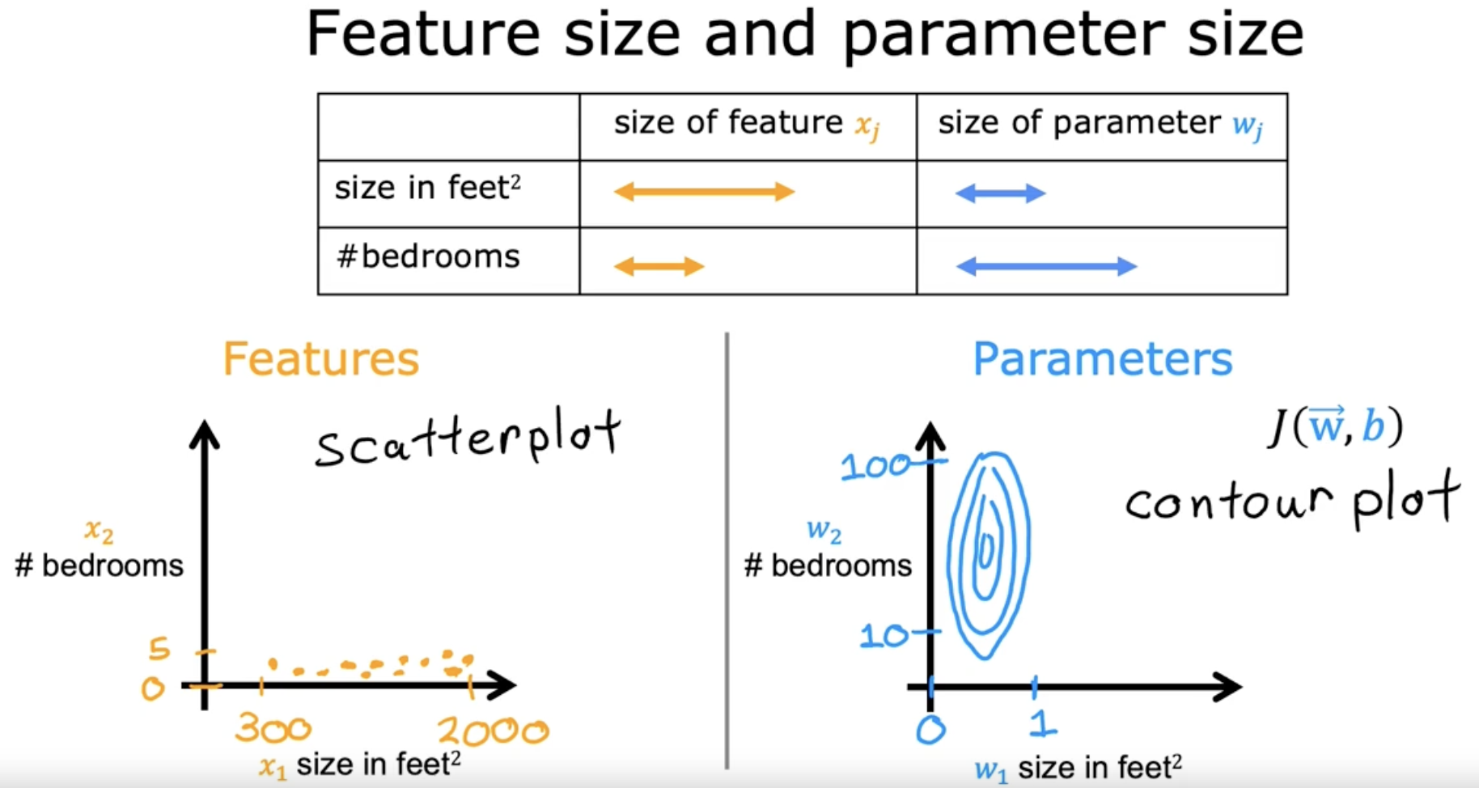

Horizontal axis 🡪 Narrow range  
Vertical axis 🡪 Wider range

Small change in w1, causes large change in cost.  
Small change in w2, won’t affect the change in cost.

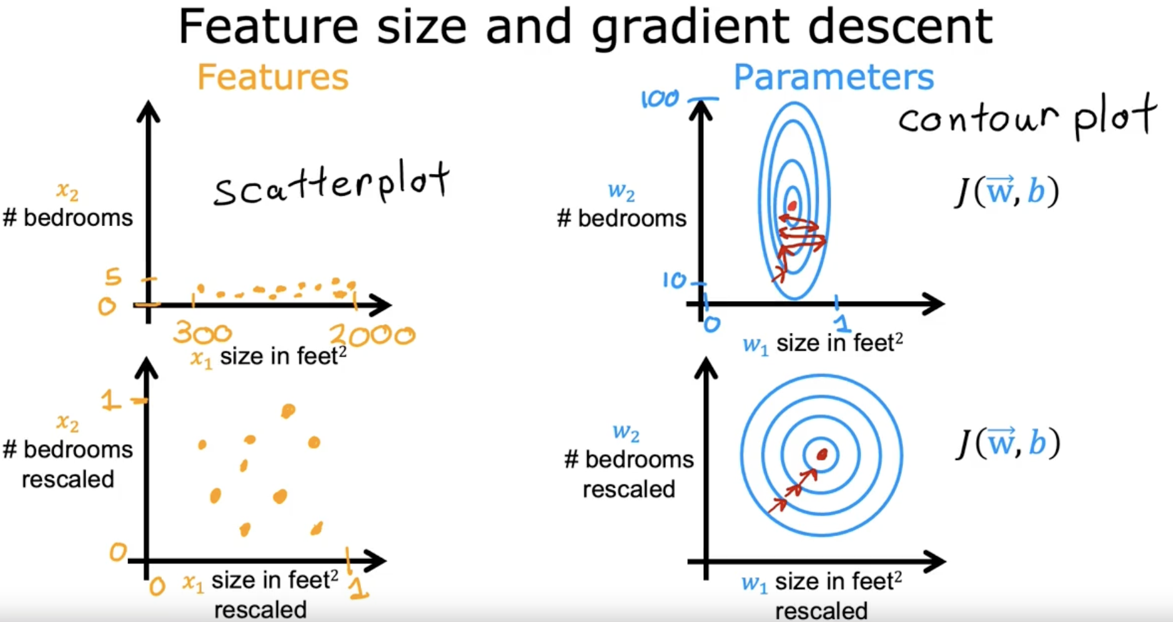

When you have different features that take on very different ranges of values, it can cause gradient descent to run slowly but re-scaling the different features so they all take on comparable range of values. Because speed, upgrade and dissent significantly.

# **Feature Scaling part-2**

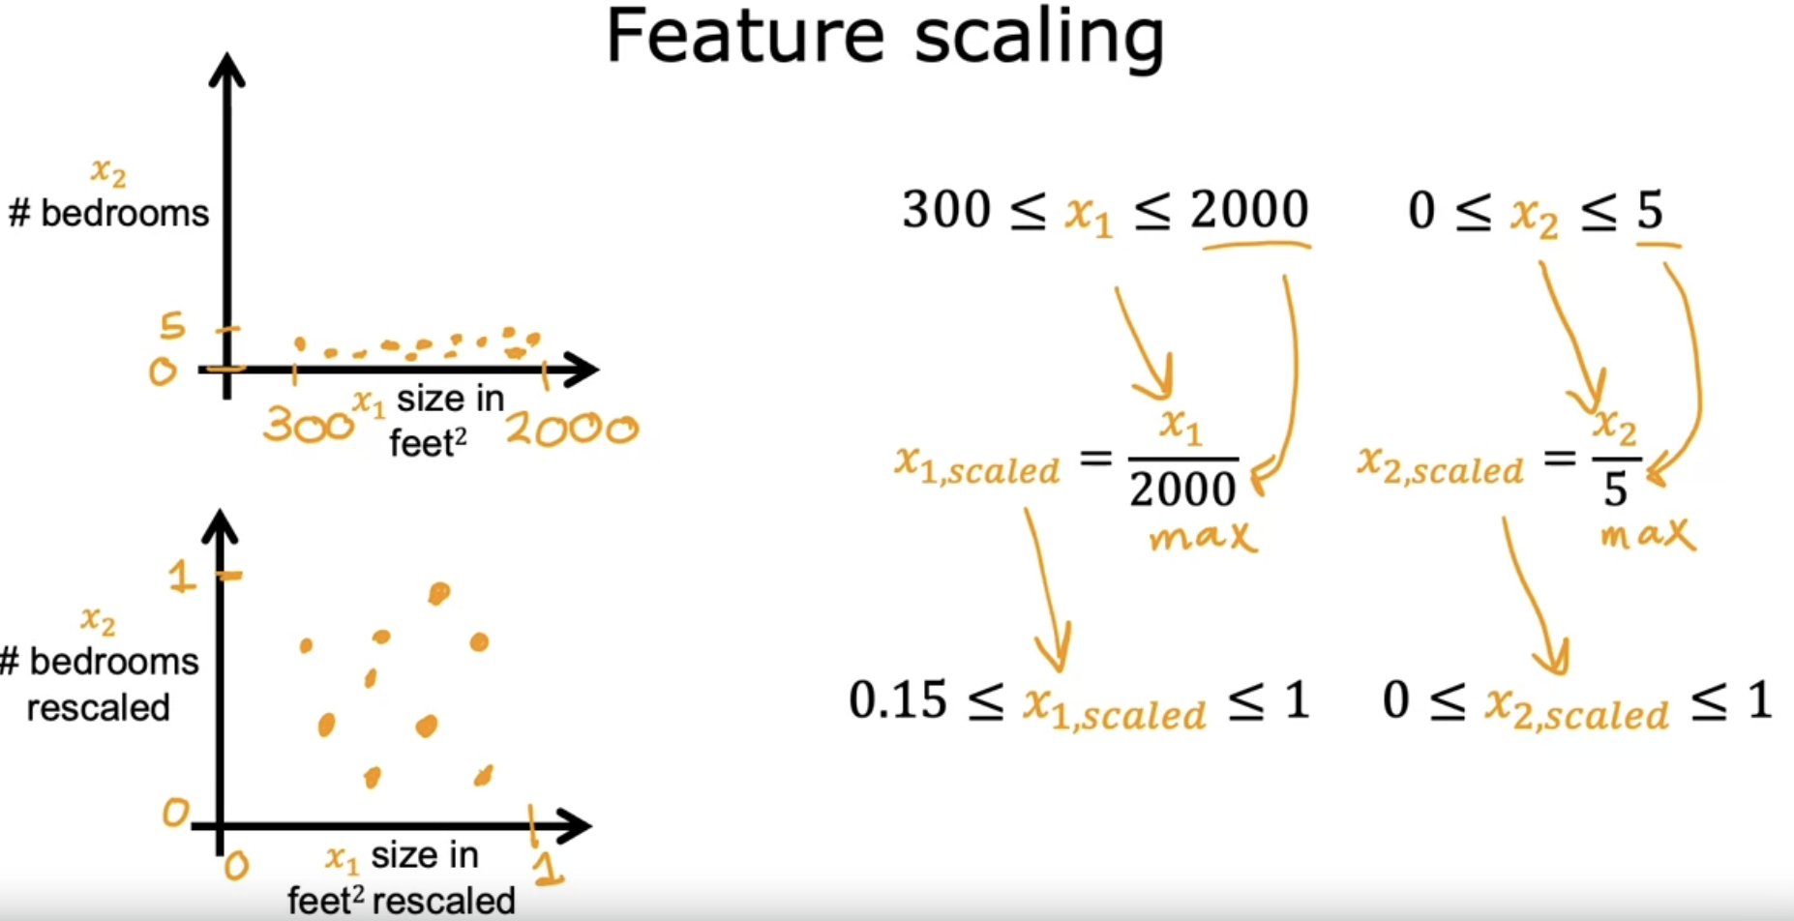

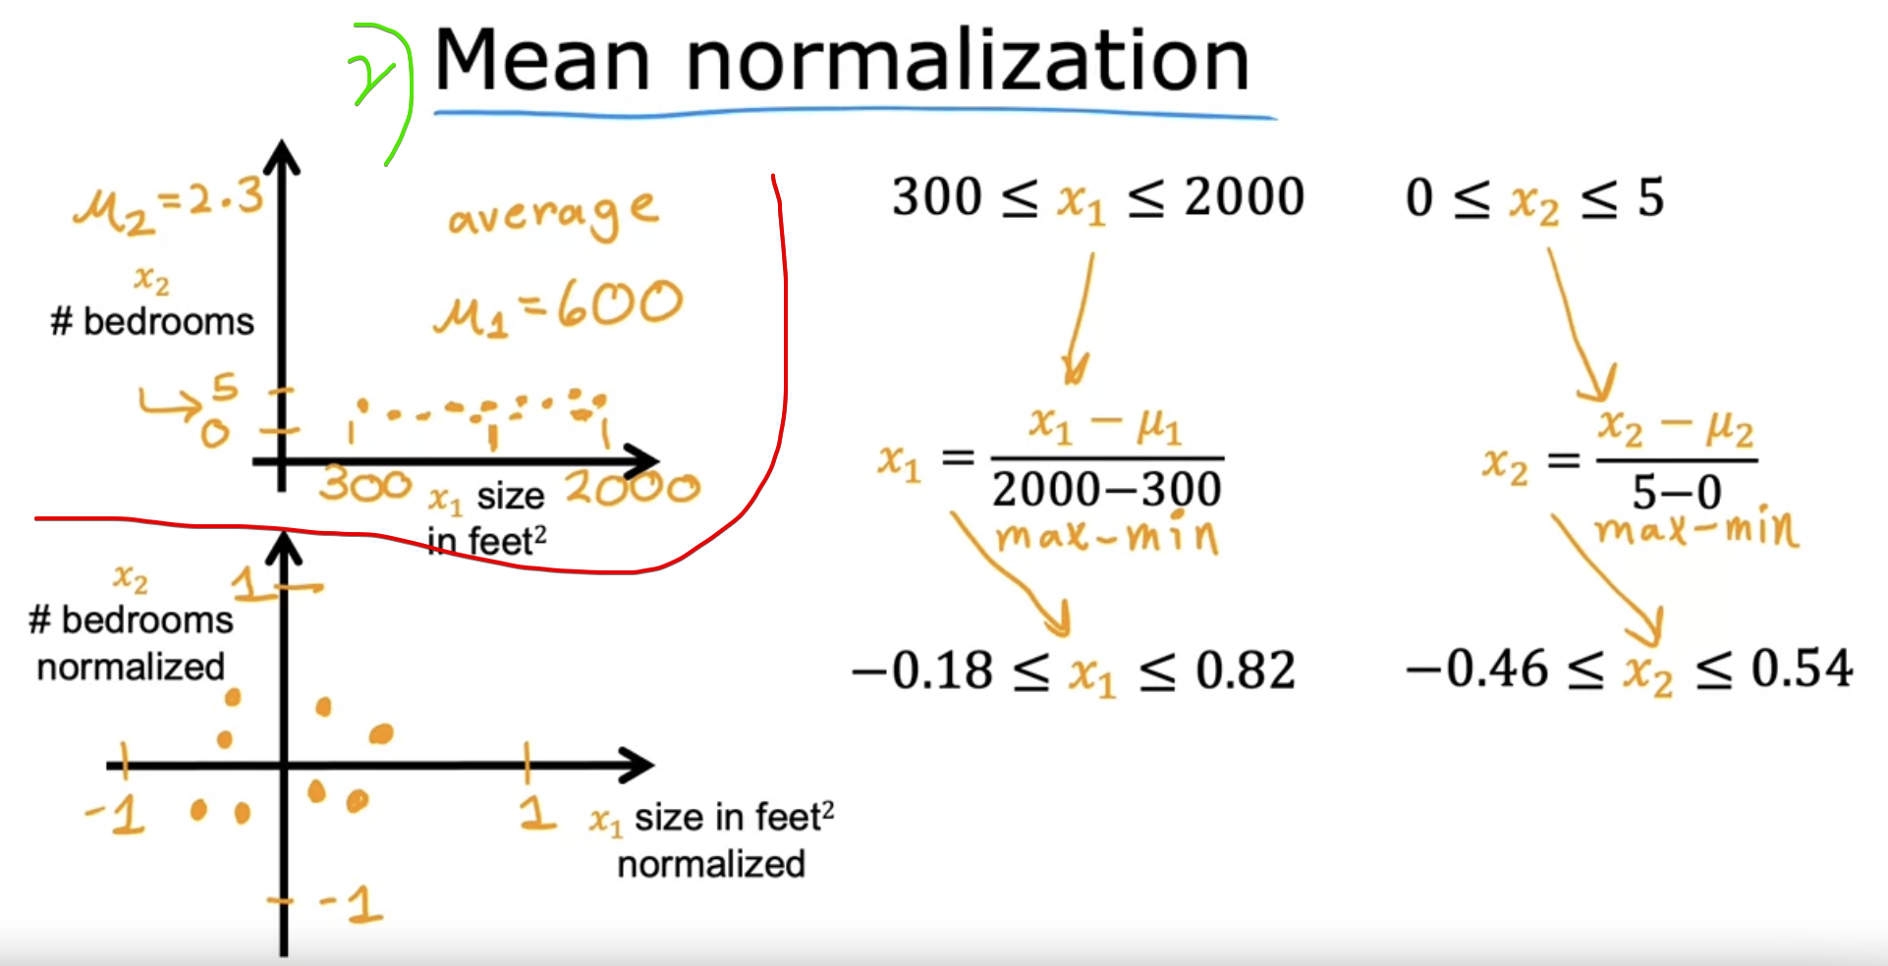

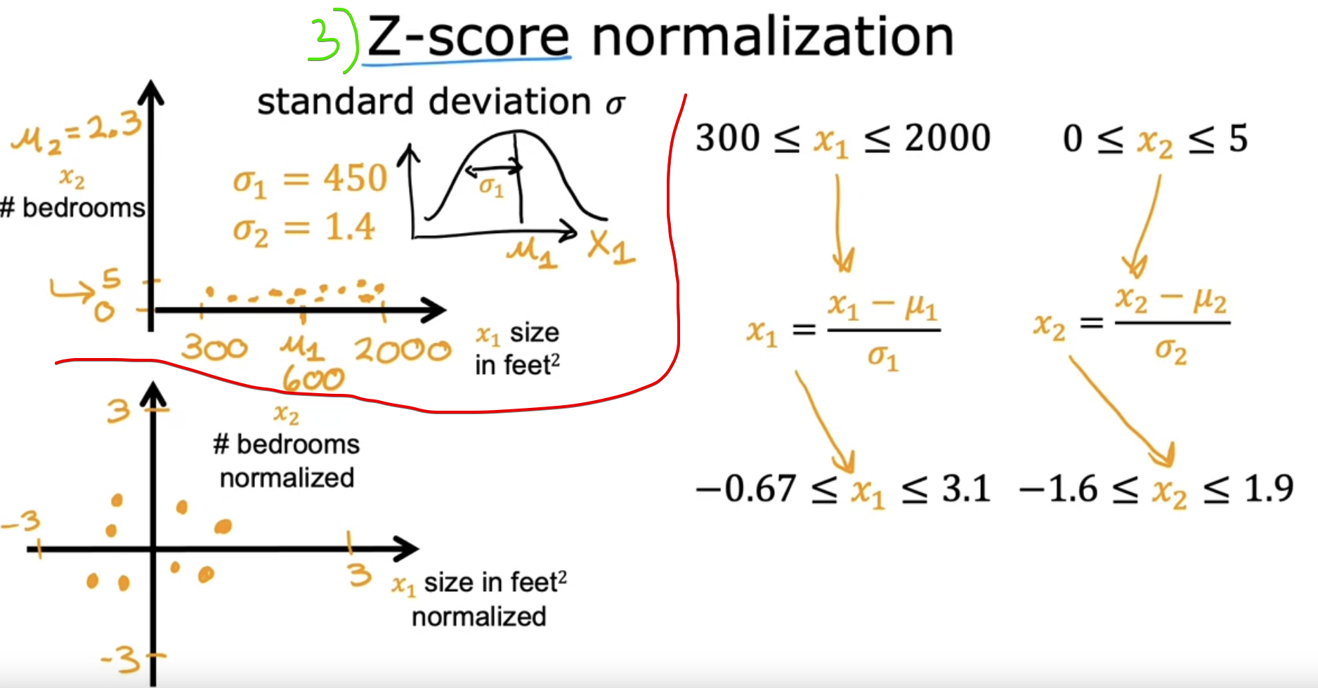

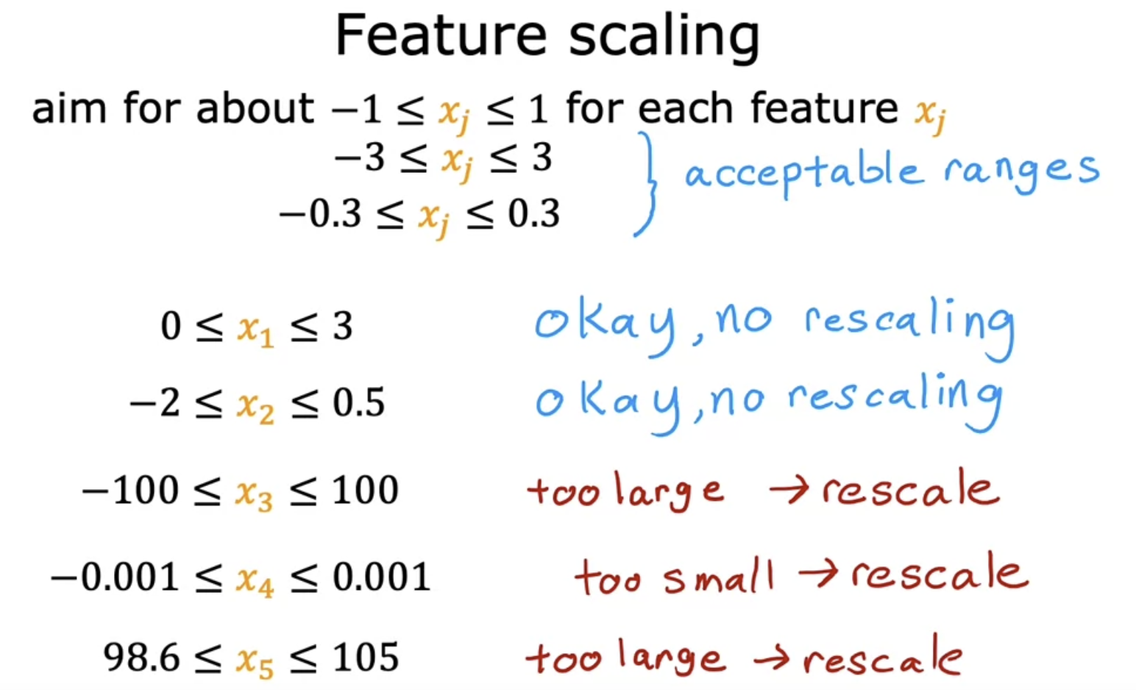

Patient’s temperature 🡪 also very large to be scalable

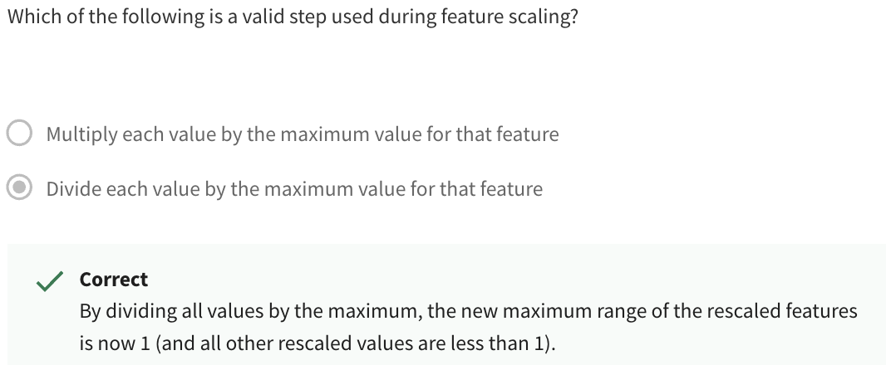

Lets see whether this feature scaling helps in Gradient Descent converging/diverging ???

# **Checking gradient descent for convergence**

Good Gradient Descent  
After every iteration, the cost function must be reduced.

If the cost function increases after iterations, then the learning rate must be high.

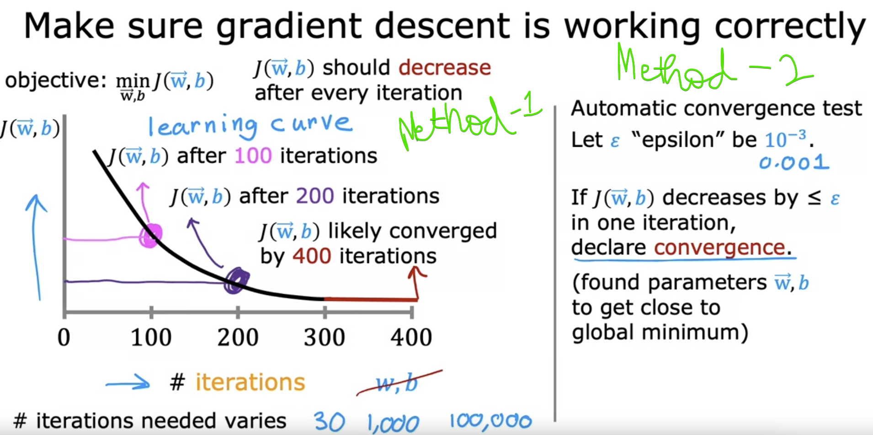

By the way, the number of iterations that gradient descent takes a conversion can vary

a lot between different applications.

In one application, it may converge after just 30 iterations.

For a different application, it could take 1,000 or 100,000 iterations.

It turns out to be very difficult to tell in advance how many iterations gradient descent needs to converge, which is why you can create a graph like this, a learning curve.

# **Choosing the learning rate**

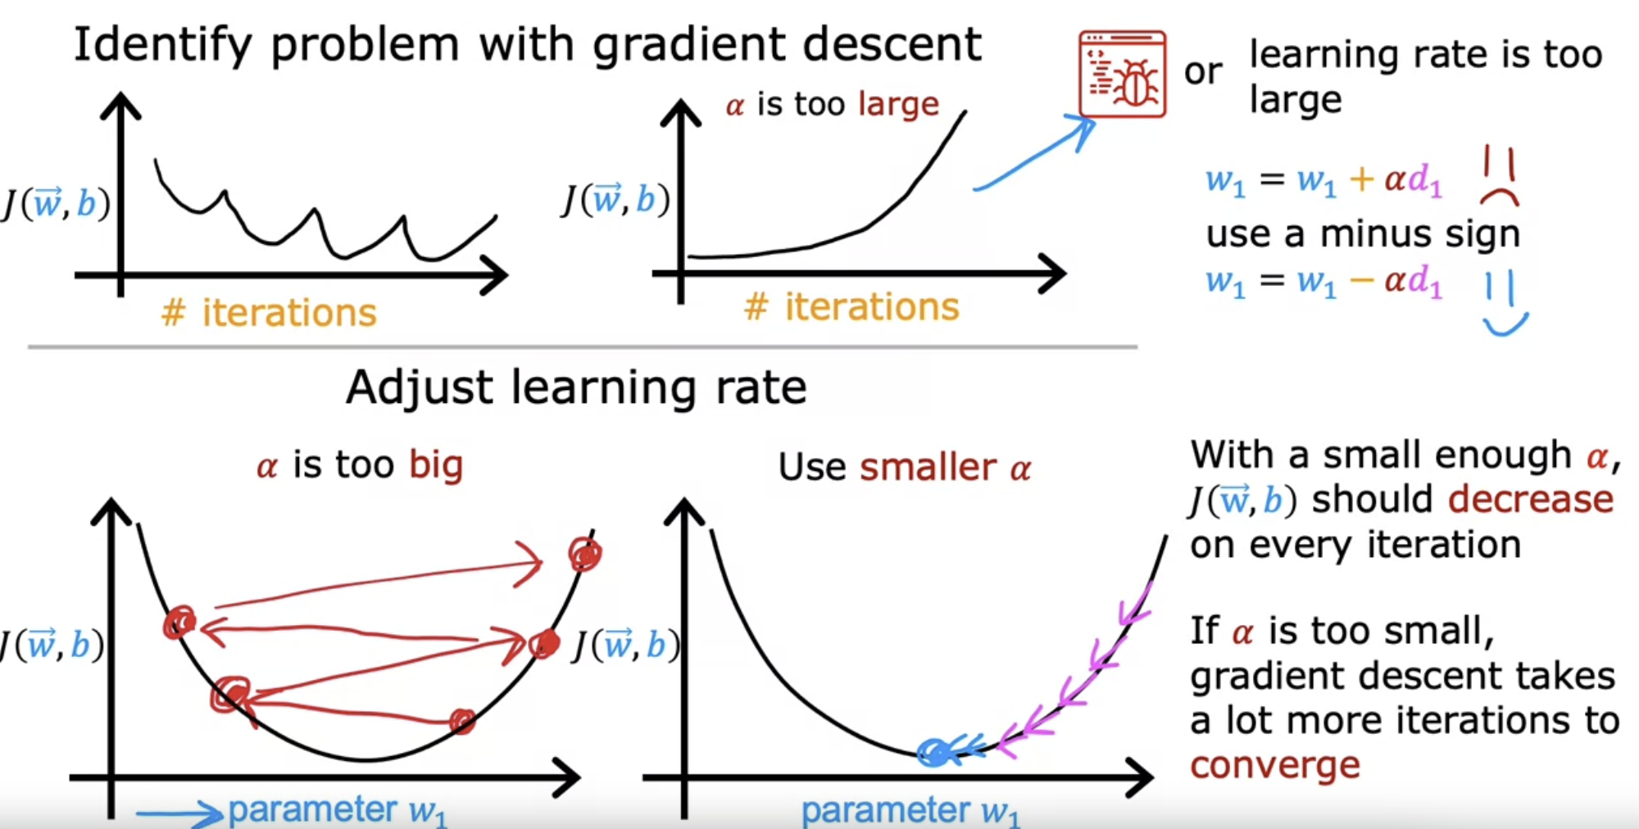

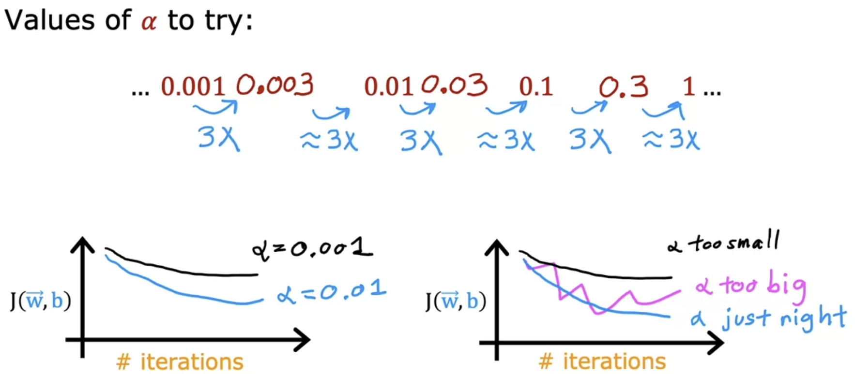

After multiplying with 3, cost function tremendously decreased.

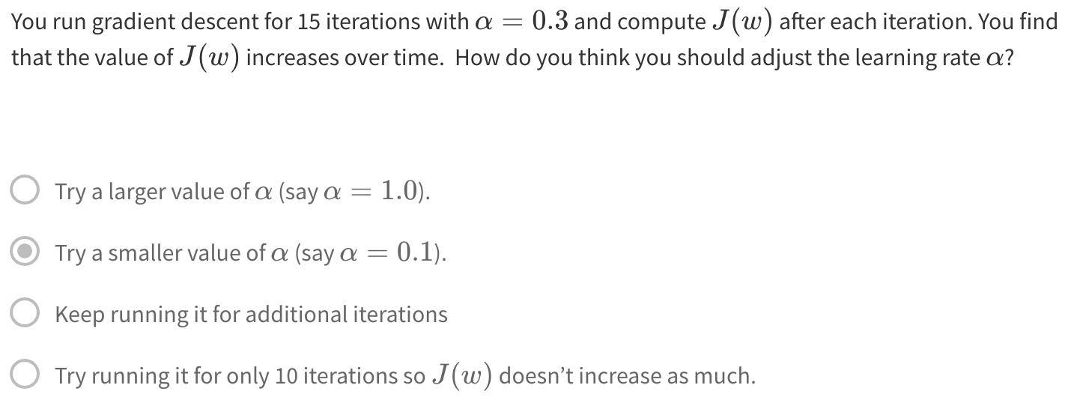  
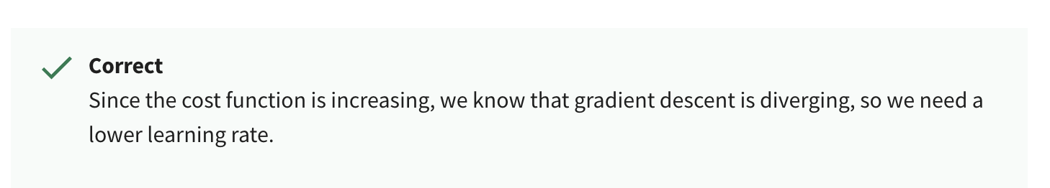

Now, there are couple more ideas that you can use to make multiple linear regression much more powerful.

That is choosing custom features, which will also allow you to fit curves,  not just a straight line to your data.

Refer Feature_Scaling_and_Learning_Rate_Soln.ipynb file

# **Feature Engineering**

Area of the house impacts the price a lot, than frontage and depth individually.

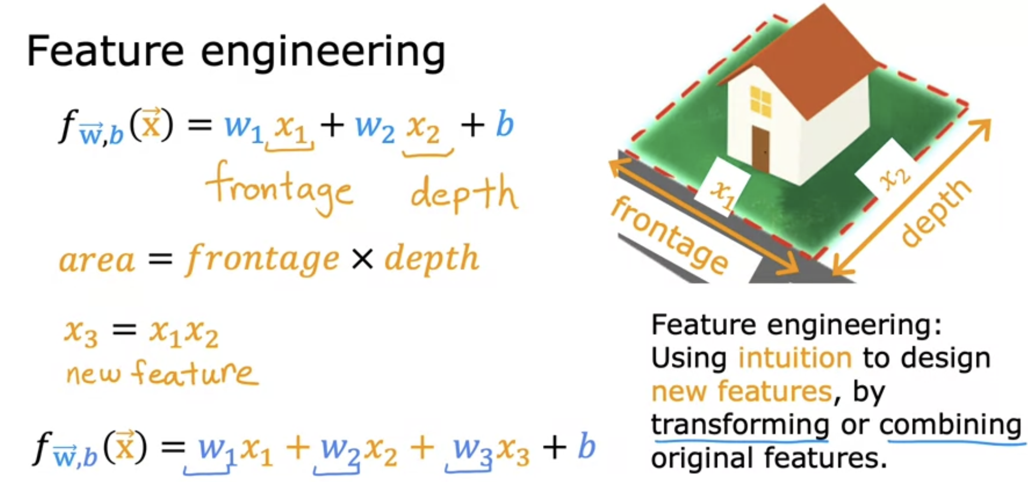

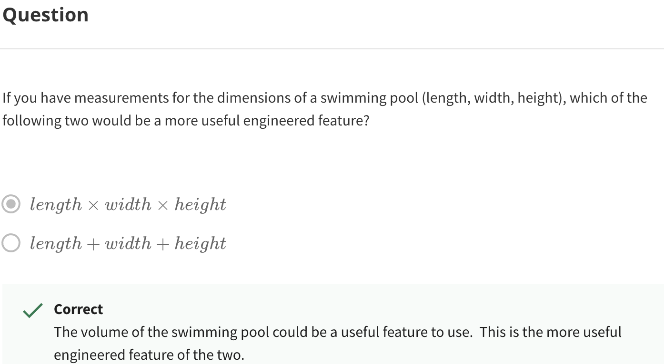

It turns out that this one flavor of feature engineering,  that allow you to fit not just straight lines, but curves, non-linear functions to your data.

# **Polynomial Regression**

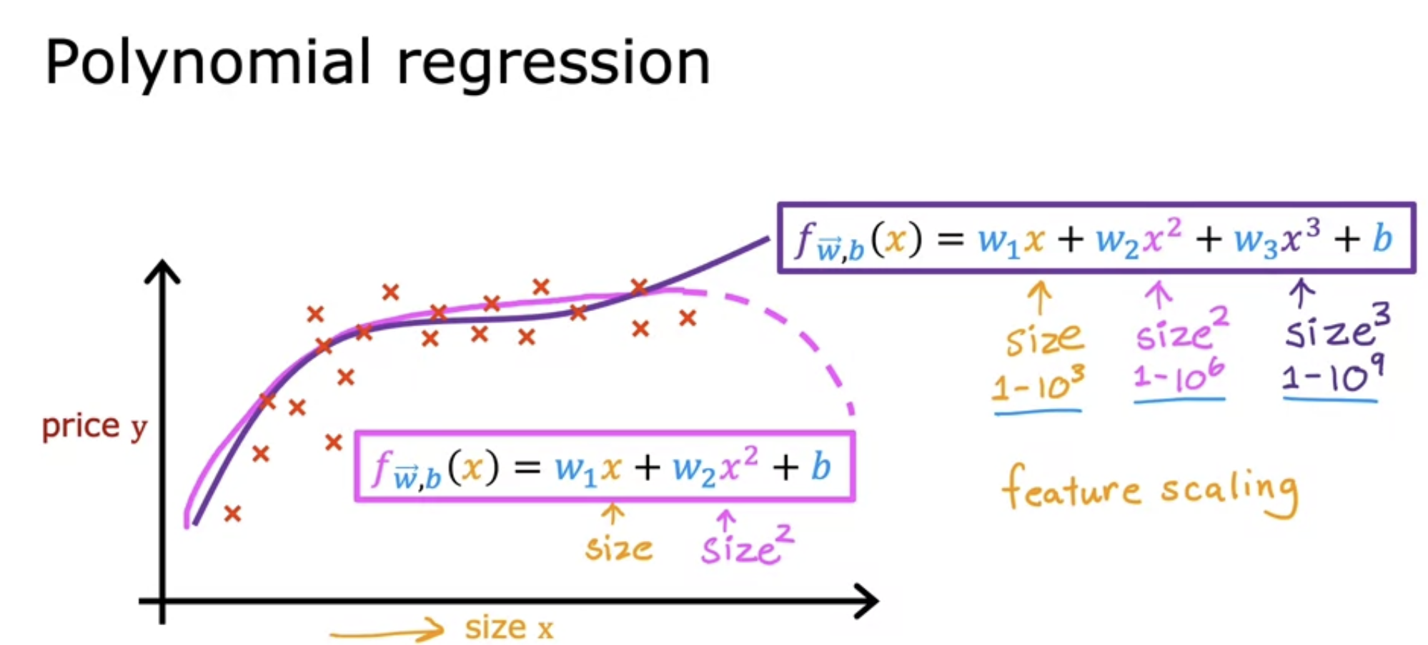

Squaring the features definitely requires Feature Scaling.

## **No feature engineering**

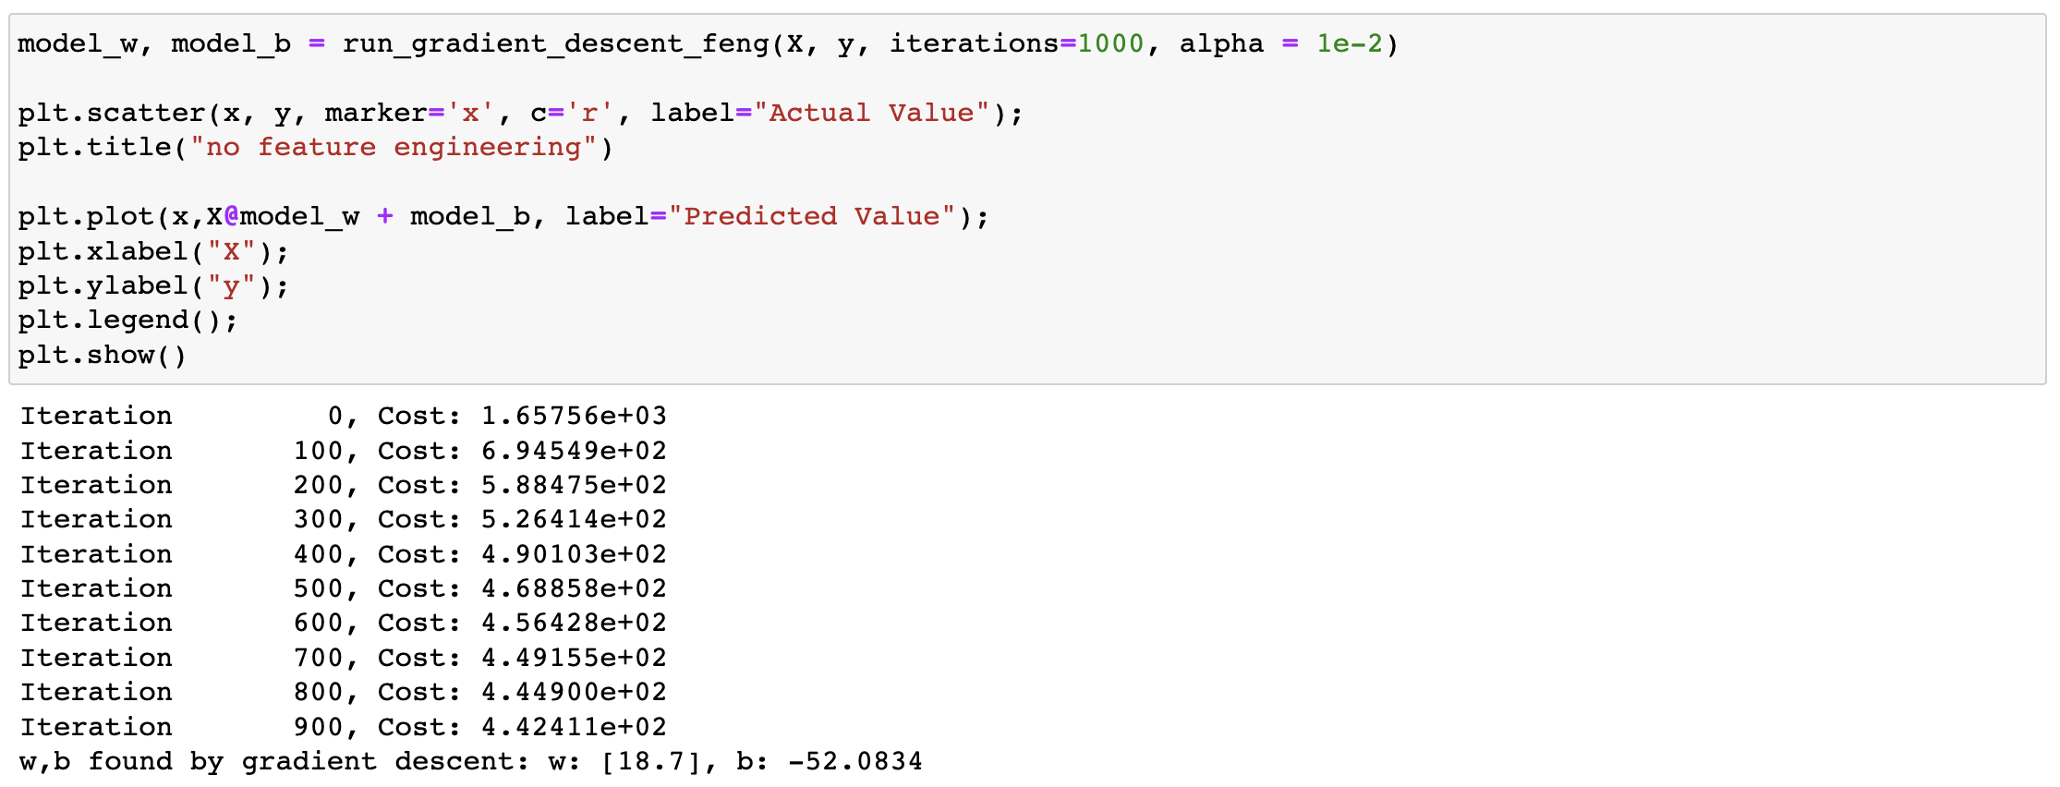  
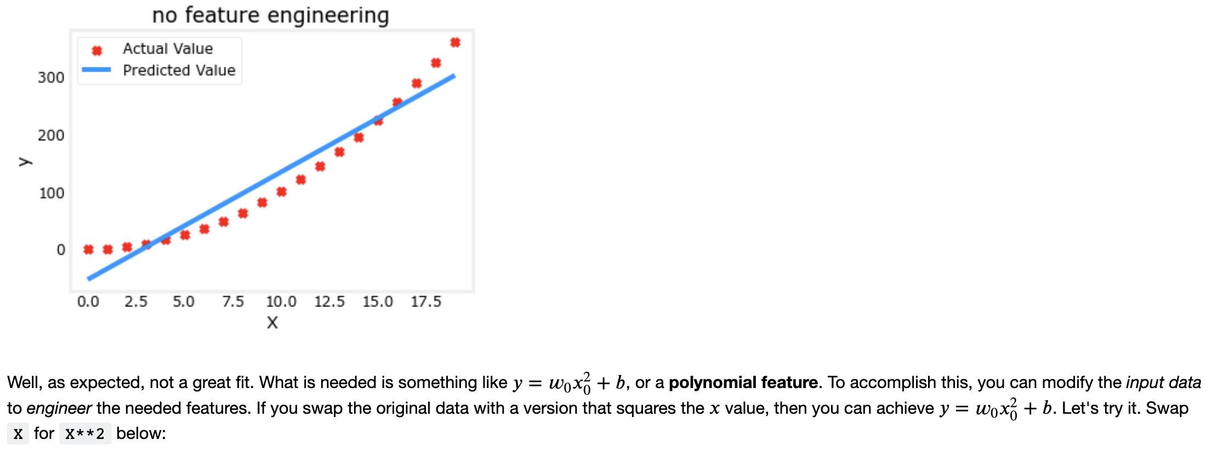

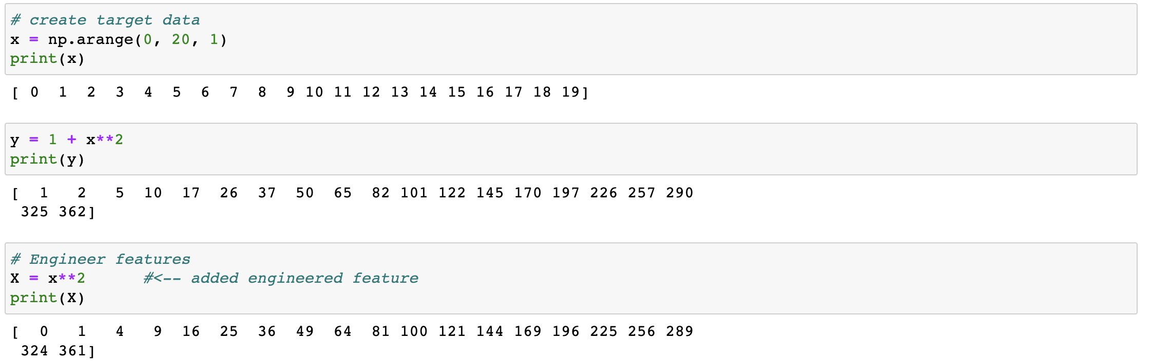  
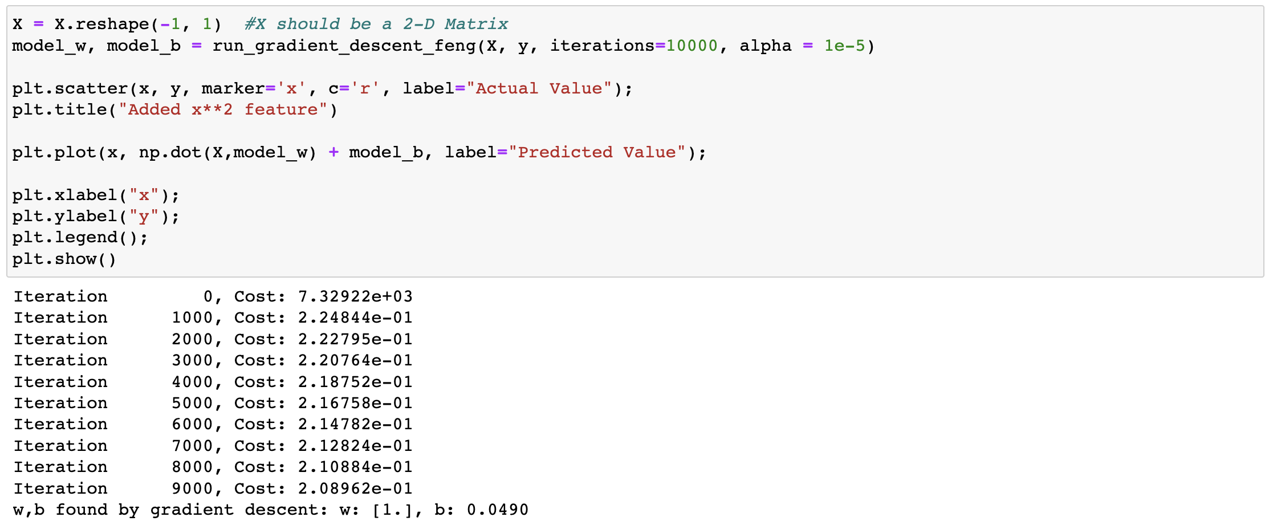  
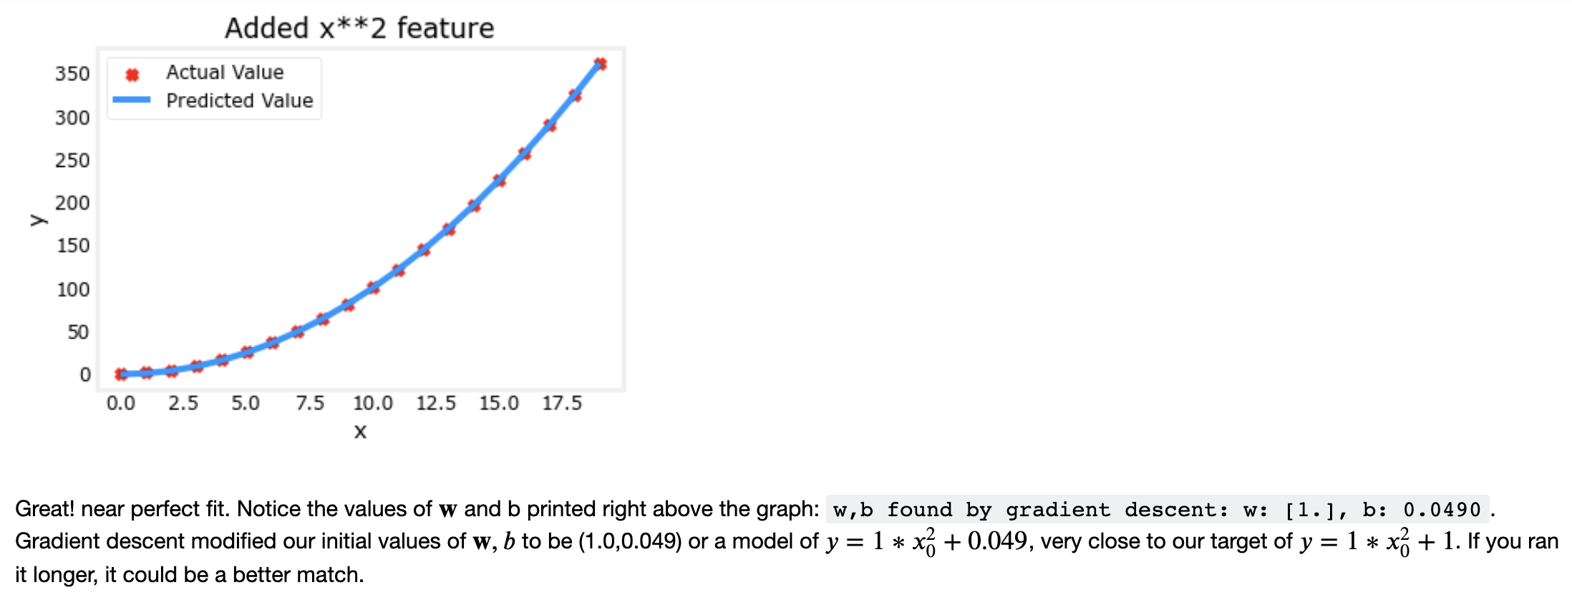

## **Without Normalization**

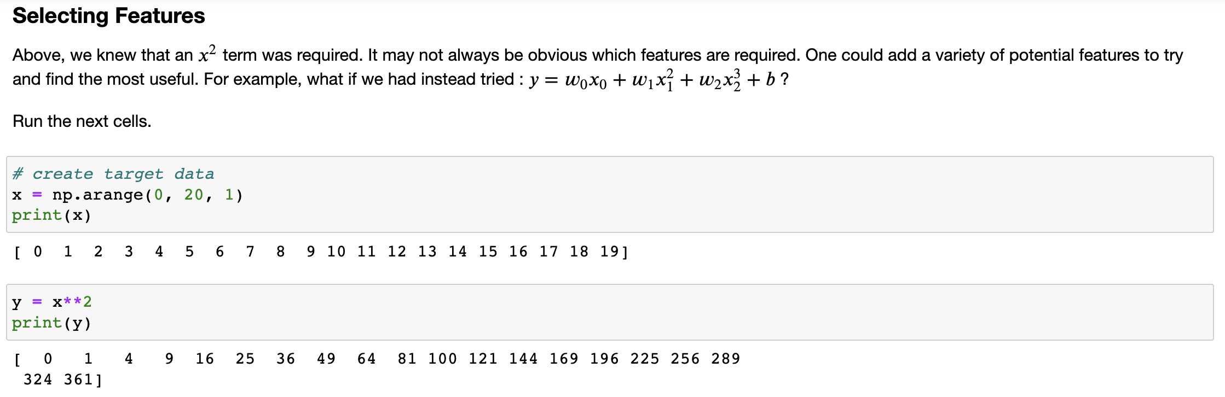  
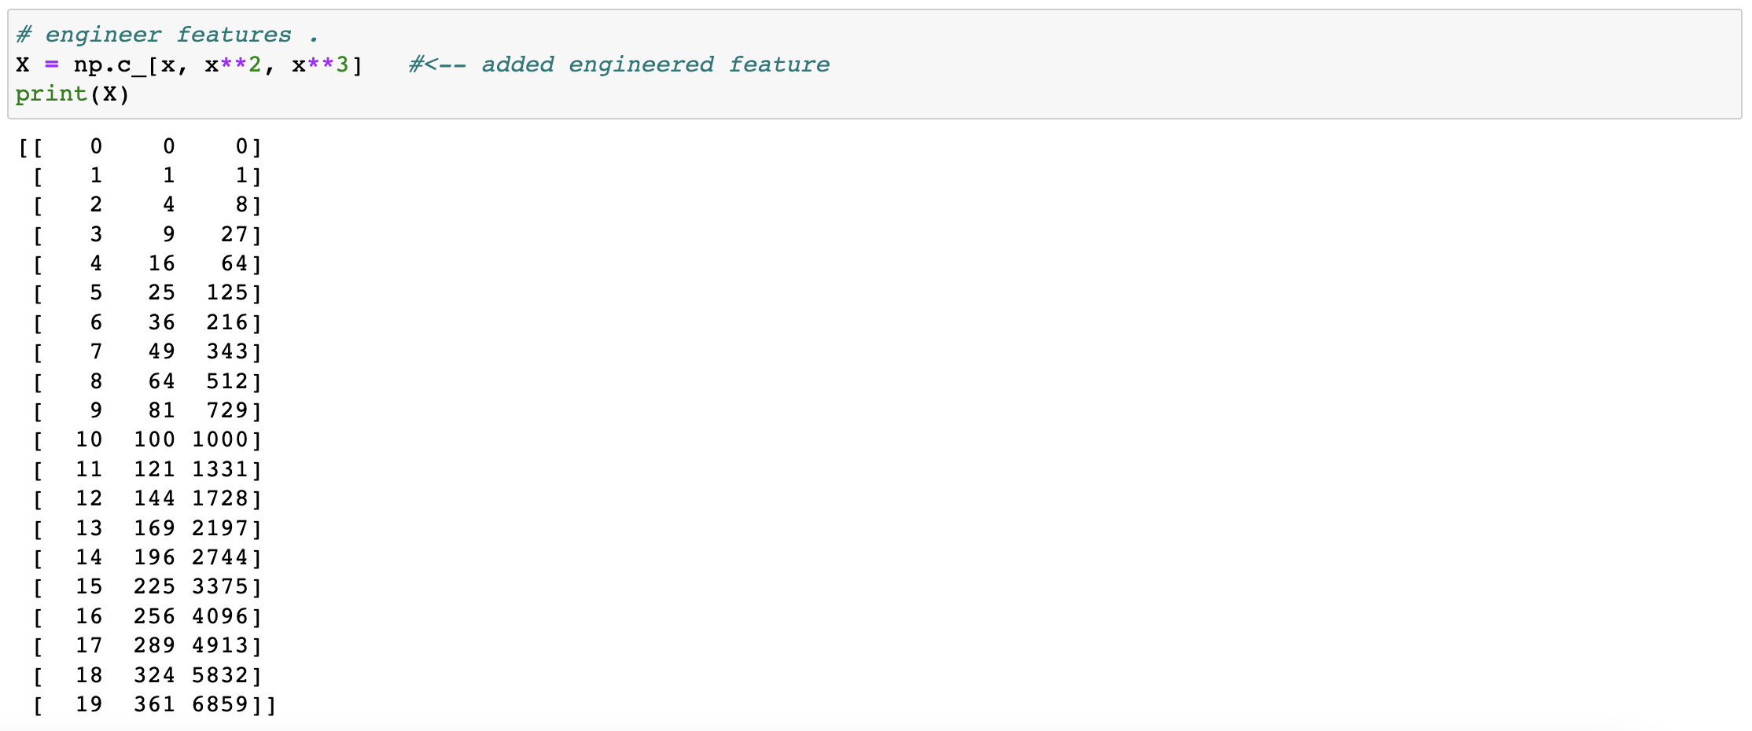

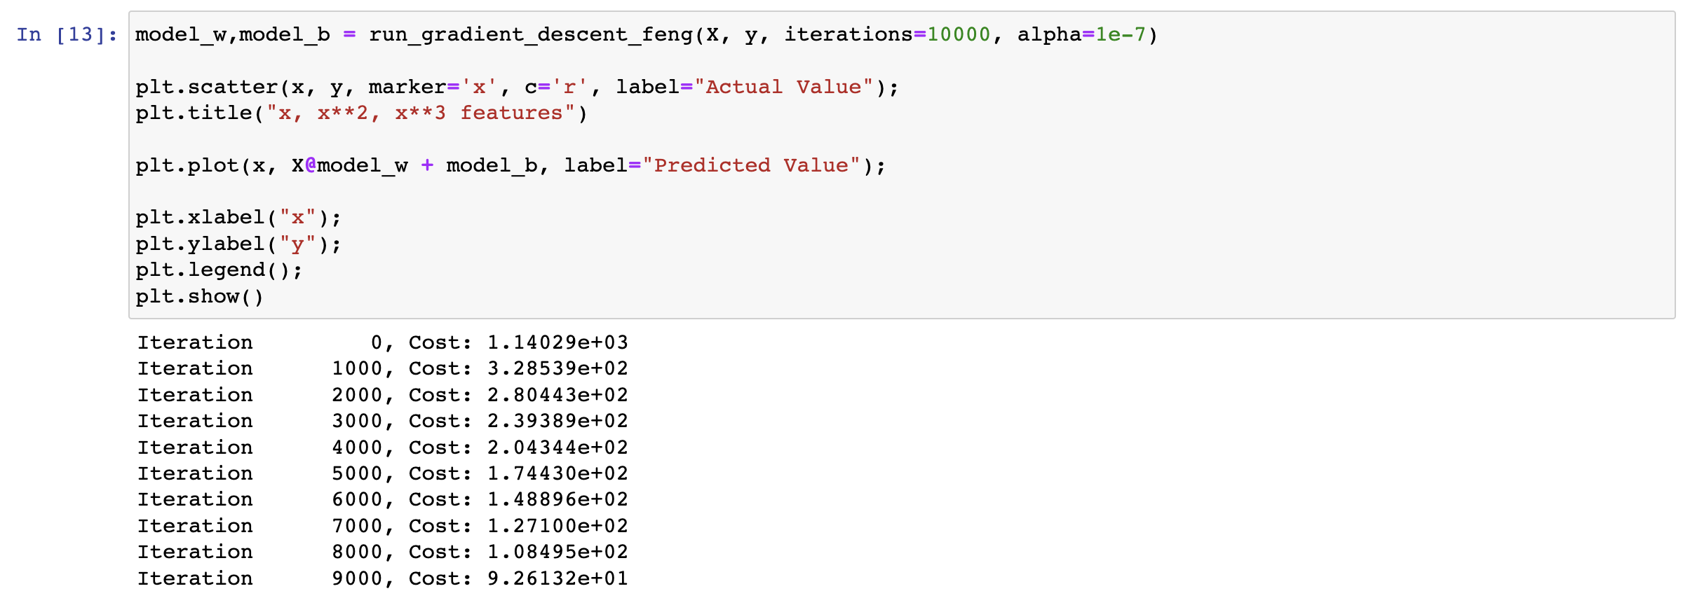  
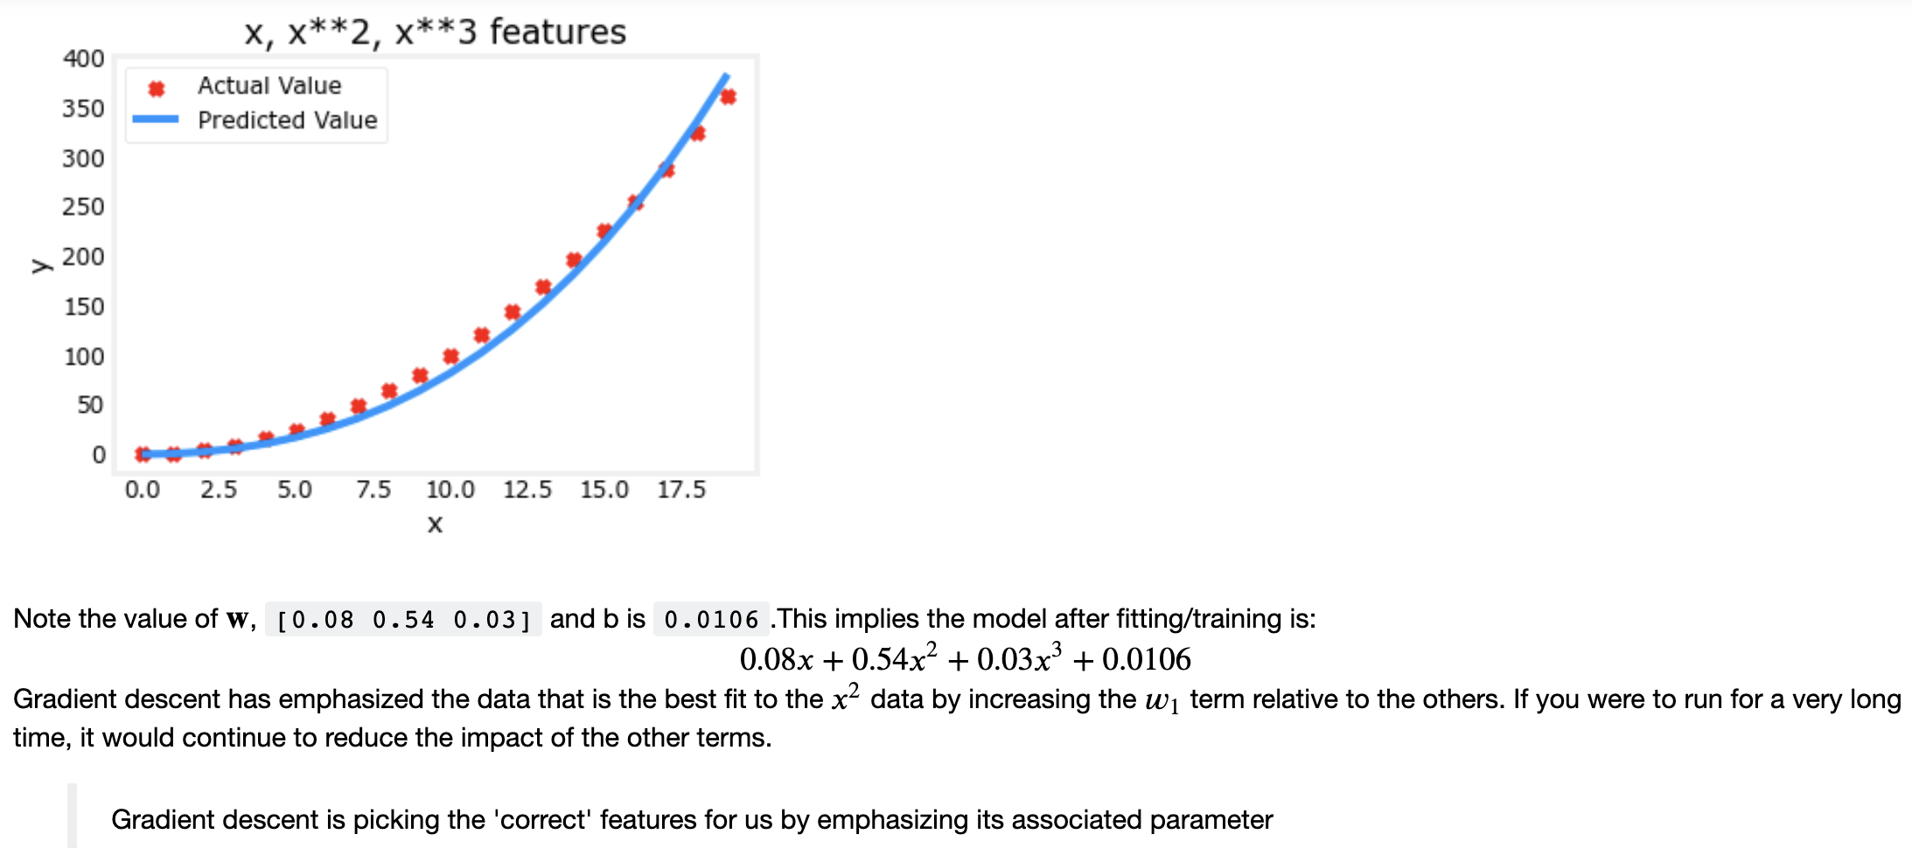

## **With Normalization**

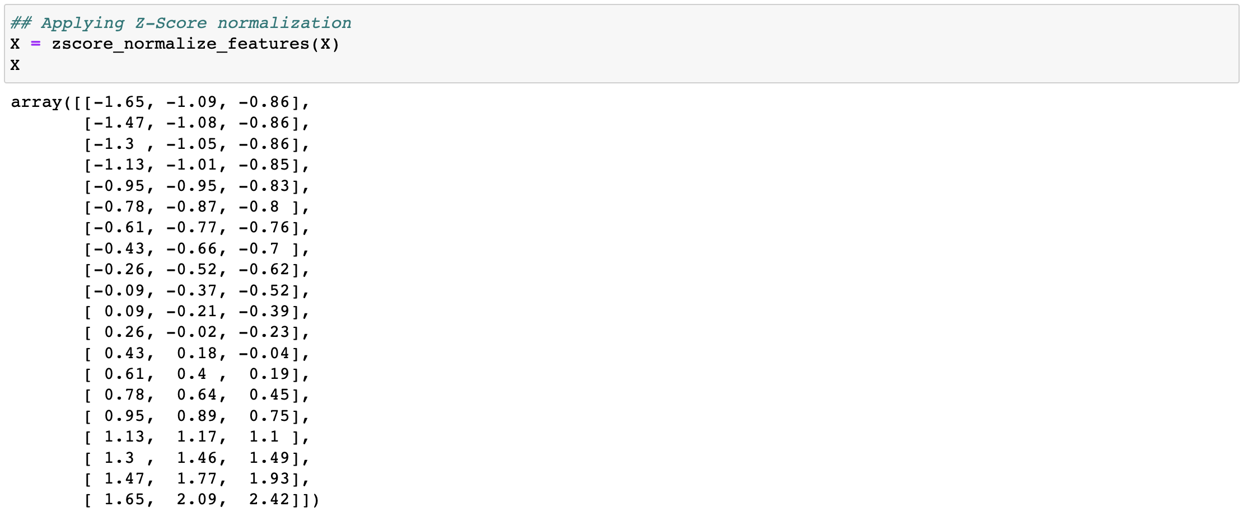

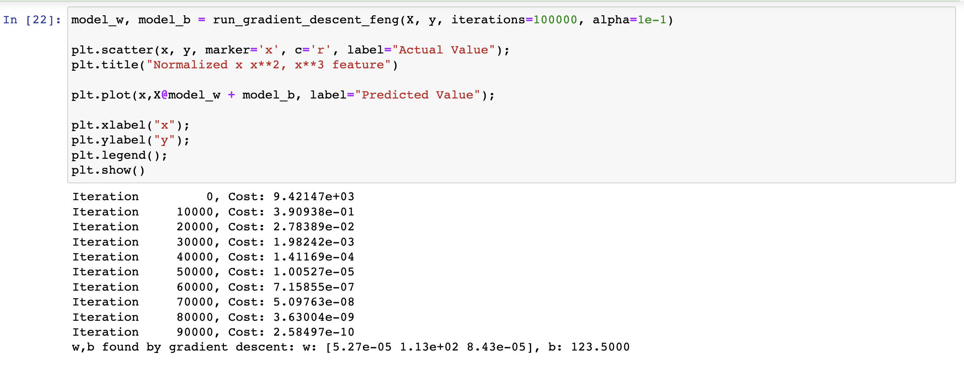  
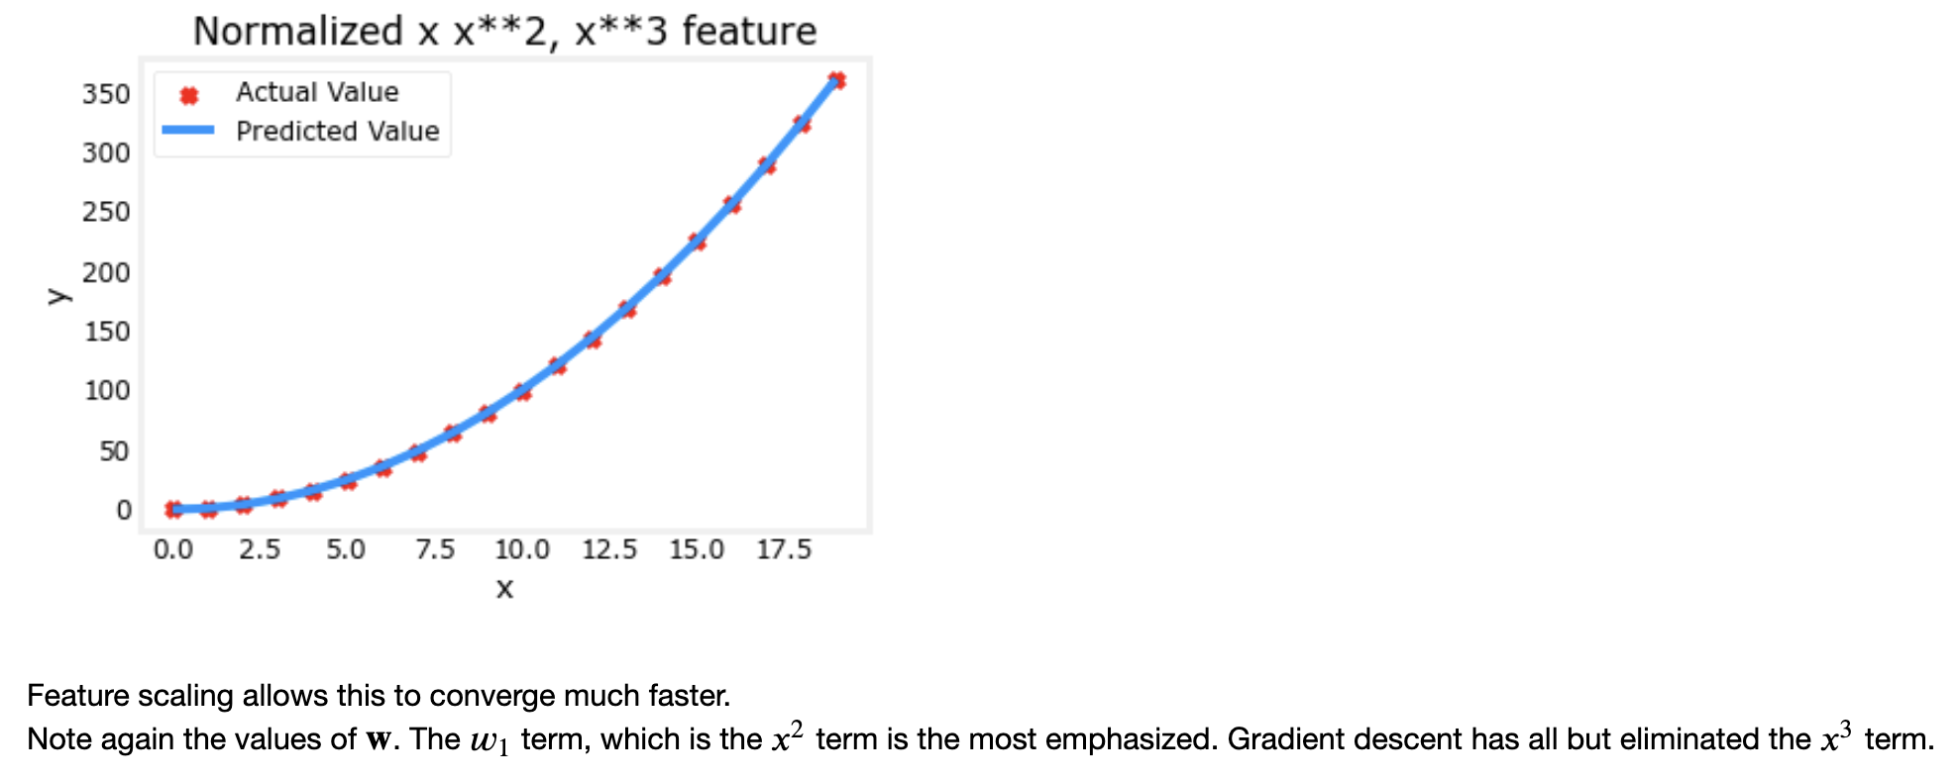

## **Complex Functions**

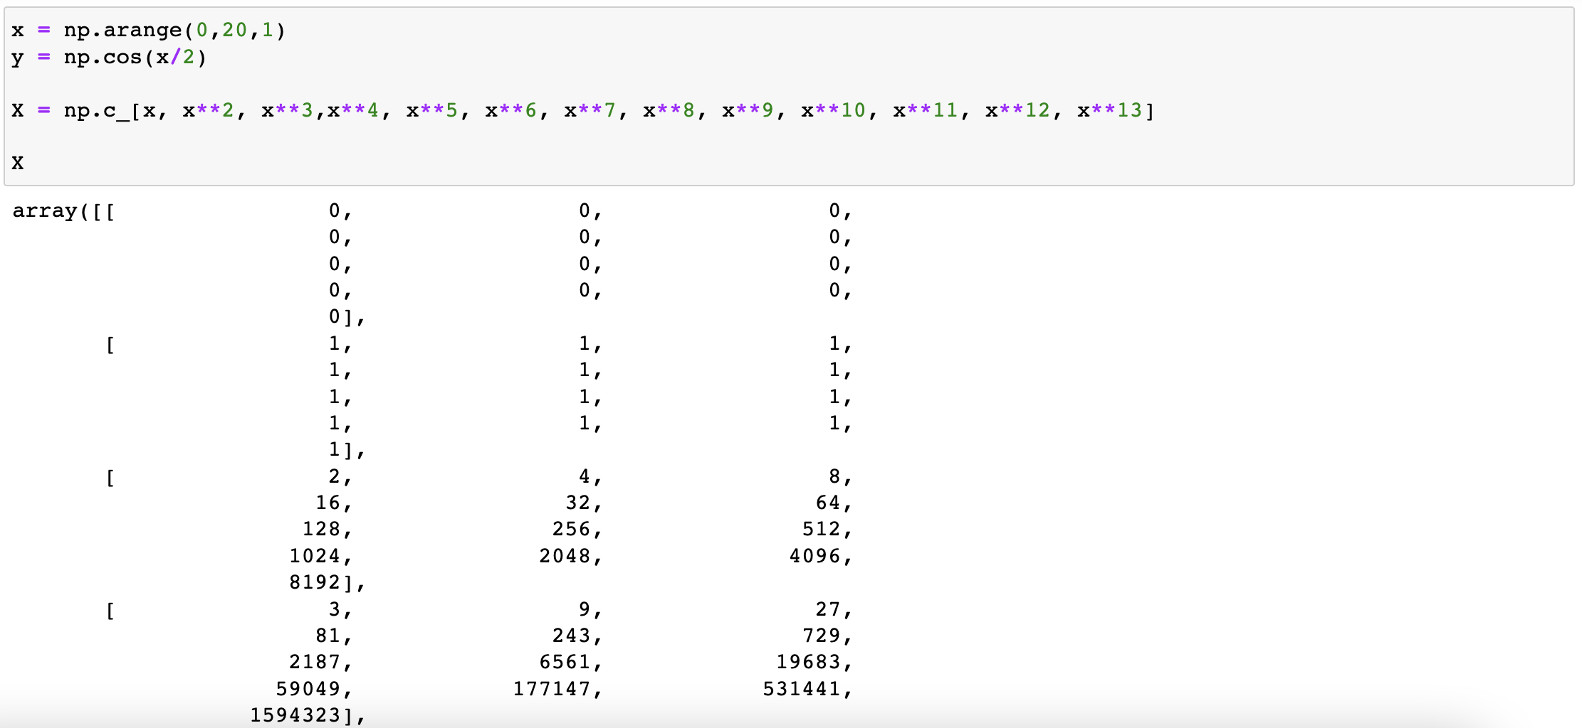

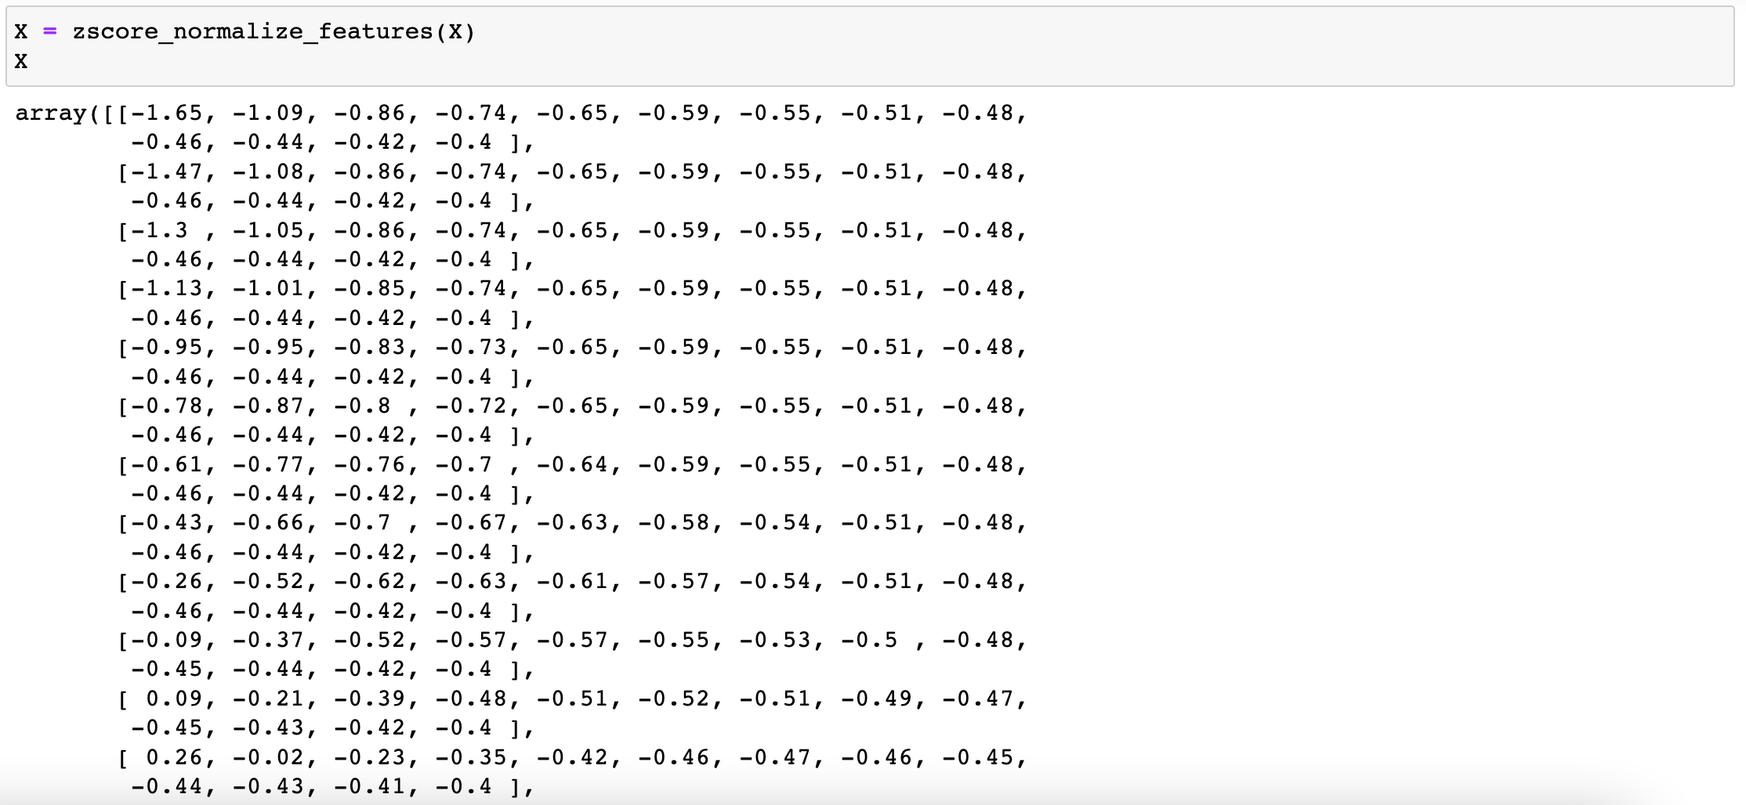  
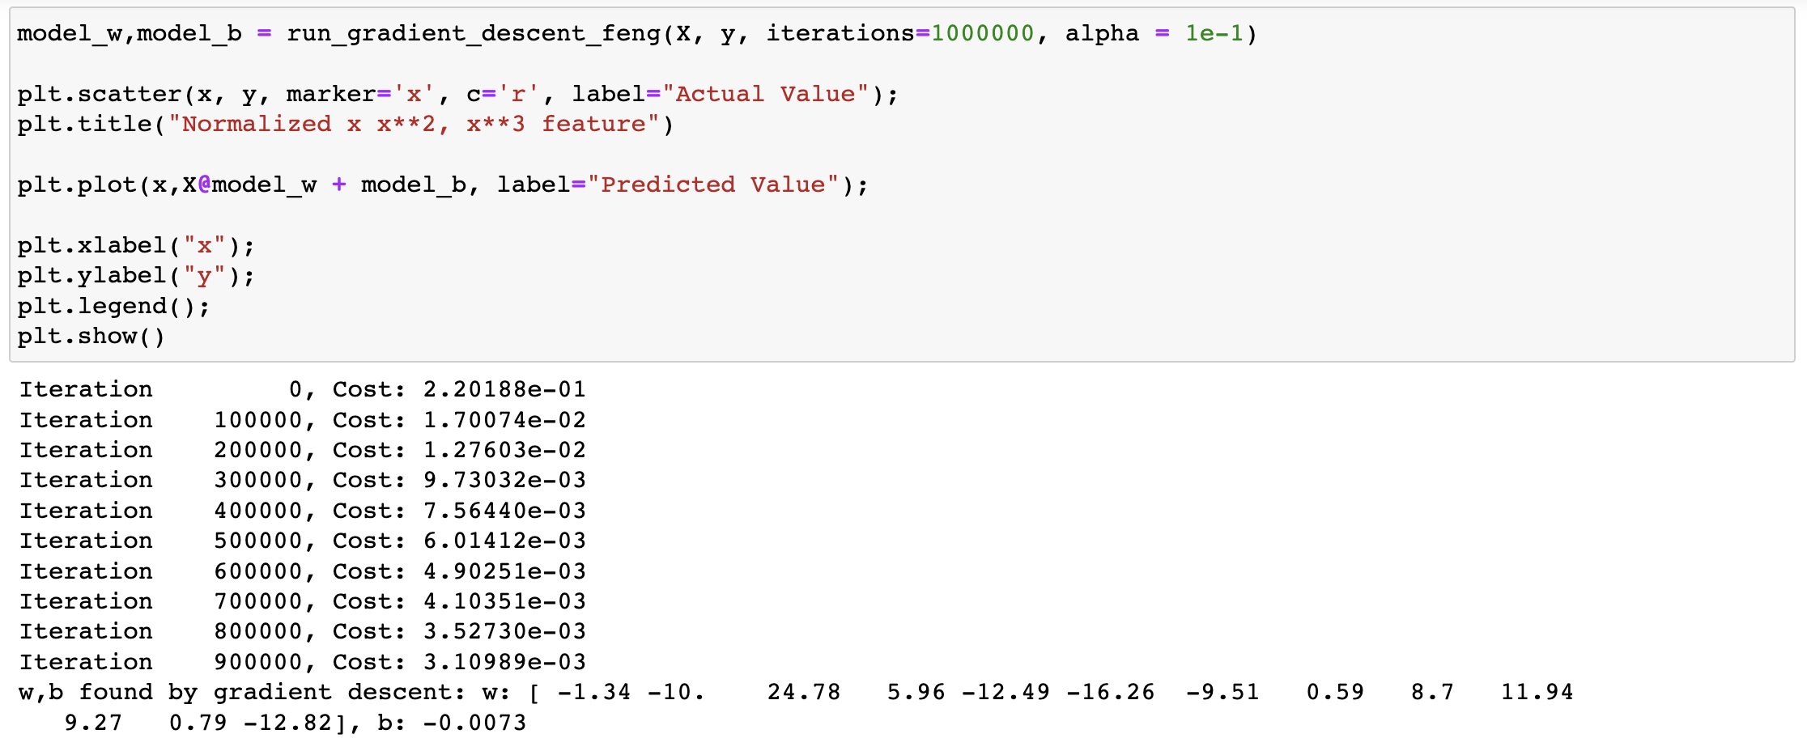  
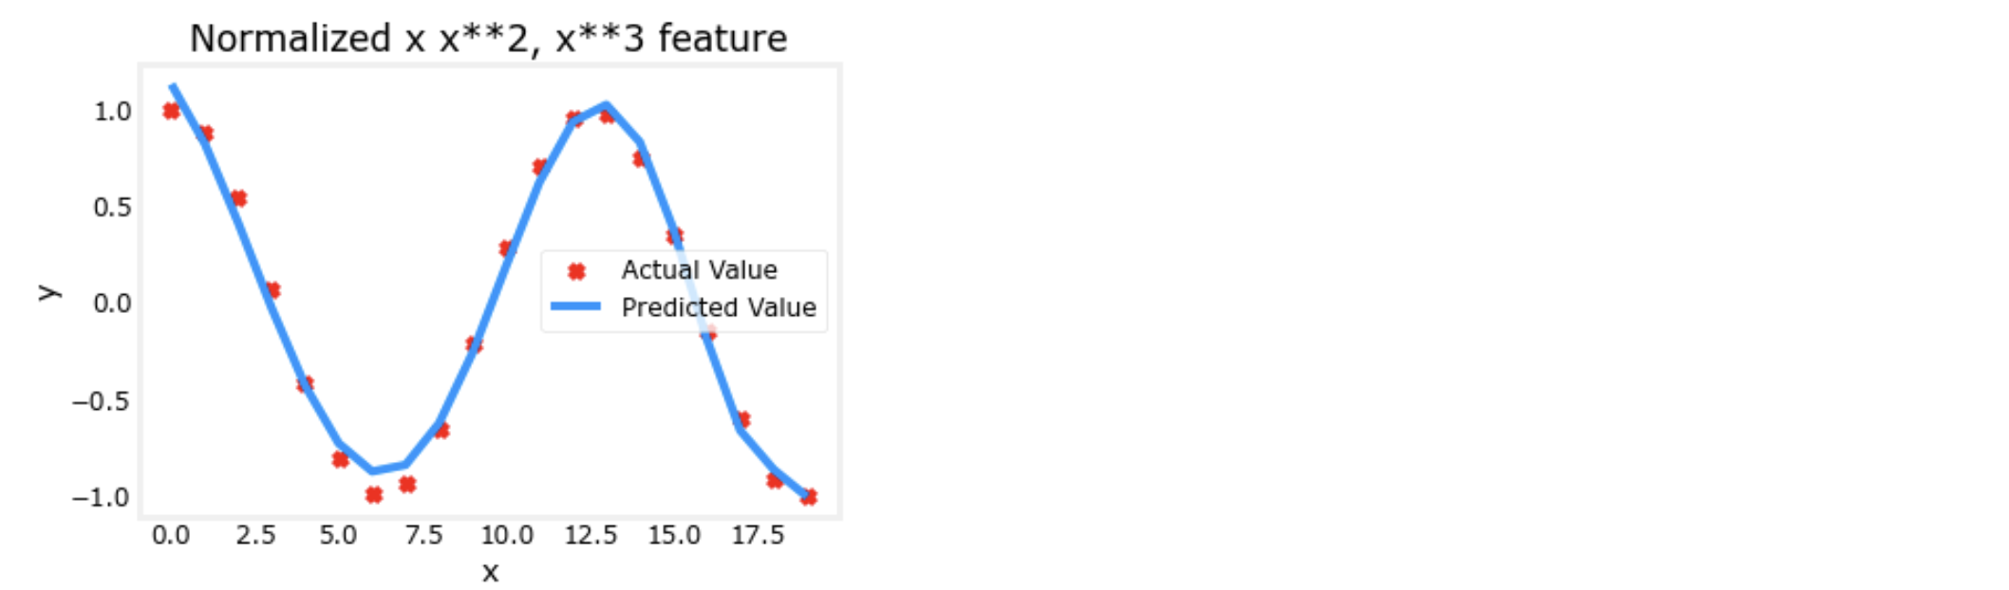

# **Quiz**

